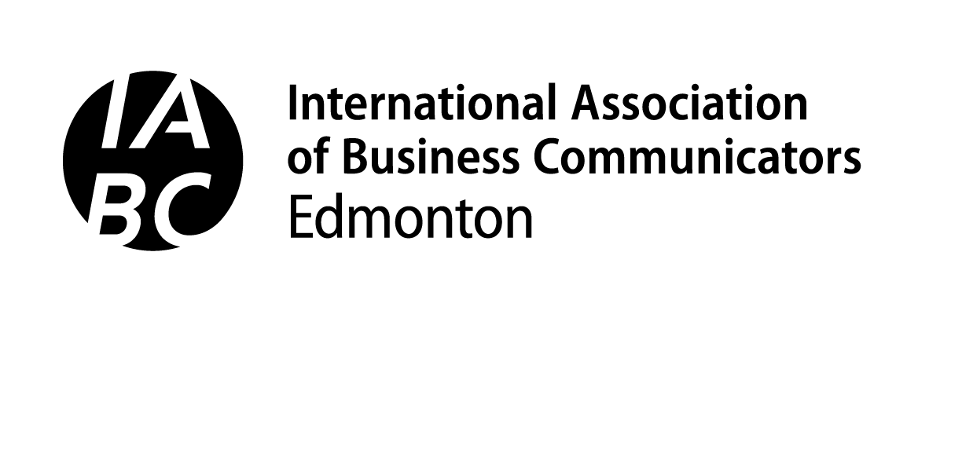
2021 CAPITAL AWARDS WORK PLAN FOR
Division 4: Communication Skills Resources

Please complete the online entry form by answering the following questions:

- Describe your organization. (maximum of 800 characters, including spaces)

- Describe the business need that led to this project being undertaken. (maximum of 1,000 characters, including spaces)

- Who was (were) the audience(s) for this project? What do you know about them in relation to the communication opportunity? (maximum of 1,000 characters, including spaces)

- What were the measurable objectives for the project? Please provide no more than three objectives, and describe how they are aligned with the business need. (maximum of 1,000 characters, including spaces)

- What were the key messages for the project? Name not more than three messages. (maximum of 1,000 characters total, including spaces)

- Describe the resources (budget, time, others) available for the project and how effectively they were managed. (maximum of 1,000 characters, including spaces)

- Provide a brief summary of how you used these insights (business need, audiences, objectives and key messages) to guide the development of your project. (maximum of 1,500 characters)

- How well were the measurable objectives met? Show the relationship between the objectives you set and the results you achieved. (maximum of 1,000 characters, including spaces)

